Data Structure Program Homework #1   
(Due: AM: 12:00, March 26, 2020)

* In the class, we demonstrate a program which can read student data from one file, i.e.,   
  **student < list1.txt**

The execution result looks like

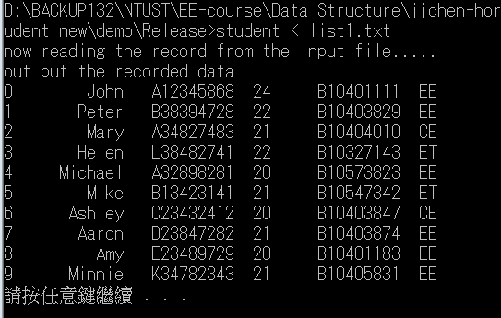

where the student record comprises name and age.

* Because the console mode is not easy to execute, you can use the file open mode. You can unmark the process1() function and use the file_process().  
  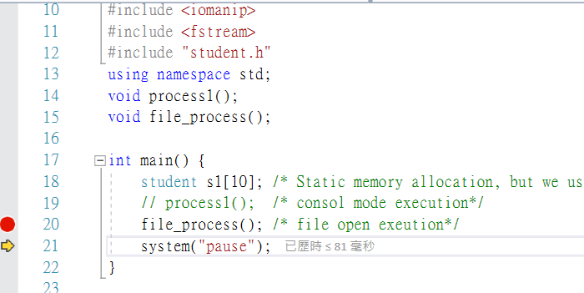

The list1.txt should be placed out of directories “Release” and “Debug” if you use file open mode.

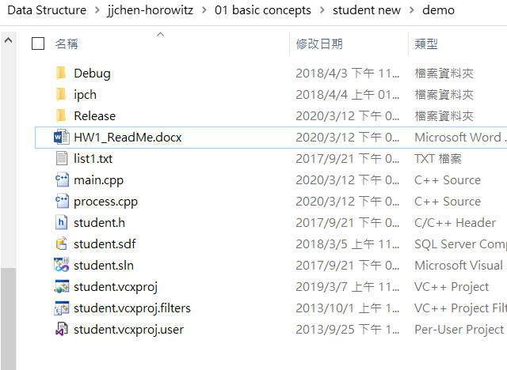

* Please modify the program such that when the input file is changed to list2.txt whose contents are as follows.

12 // number of student record

John A12345868 24 B10401111 EE 89 89 81

Peter B38394728 22 B10403829 EE 90 80 70

Mary A34827483 21 B10404010 CE 85 85 85

Helen L38482741 22 B10327143 ET 85 88 90

Michael A32898281 20 B10573823 EE 77 85 92

Mike B13423141 21 B10547342 ET 85 84 85

Ashley C23432412 20 B10403847 CE 85 85 83

Aaron D23847282 21 B10403874 EE 90 90 90

Amy E23489729 20 B10401183 EE 91 92 93

Minnie K34782343 21 B10405831 EE 85 85 86

Trump X89384828 22 B10204839 PE 80 85 84

Sarah L37829384 20 B10304837 EE 85 89 72

where the three numbers after each record are examination scores.

* After executing your program: **student < list2.txt**

the output should look like:

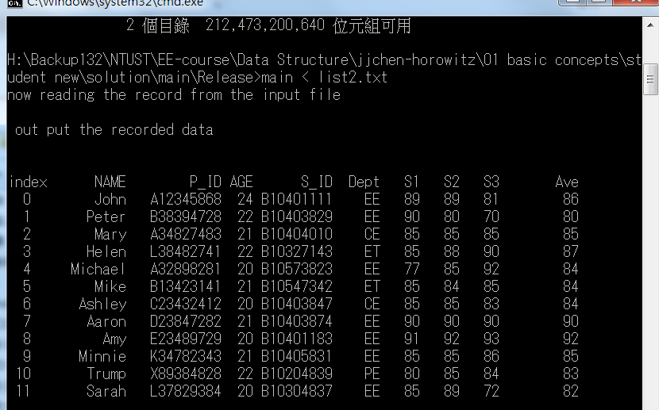

Note that the last column is the average score;

* For you to quickly start your programming, a reference program is provided for you. Please check the HW1 from the course website to download this program
  + (60%) Modify from the given program to read the scores from the file and print them out.
  + (10%) Compute the average and print it out at the last column.
  + (10%) Provide the function to find out the student names with the **highest** average score and the **lowest** average score.
  + (10%) print the name and score from the highest to the lowest.
  + (10%) Write a short report to describe what you have done for this homework.
* You have to

1. Compress the whole project program you have finished.
2. upload to the moodle website before the due date